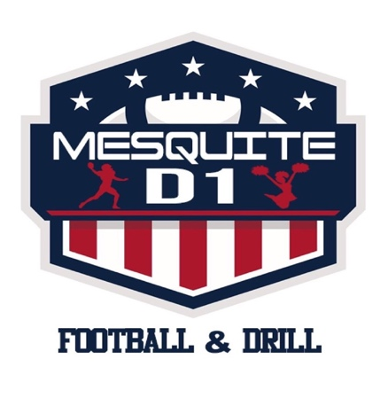
MESQUITE DIVISION 1 FOOTBALL AND DRILL
MEDICAL WAIVER AND RELEASE FORM

Participants Full Name:______________________________ Age:_____________

Date Of Birth:_________________ School Child Attends:_________________

Address:______________________ City:________________ Zip:_______________

Father Name:________________________ Mothers Name:_________________

Phone:______________________________ Phone:__________________________

As Parents/Guardian of the above mentioned child/participant of Mesquite Division Football and Drill. I hereby give my permission and approval of participation in any and all “ Mesquite Division 1 Football and Drill” (herein we will refer to as “m.d.1” activities during the current season. I hereby waive, release, indemnify, and agree to forever hold harmless “md1”, sponsors, directors, league executives, and organizations, participants and referee’s from responsibility including but NOT LIMITED to: Injuries to my child or myself, while participating in any and all “md1” activities. Furthermore, I will inform my guests, family members or friends that they will be entering “md1” events at their own risk.

I give permission for “MD1” and there designated officials to seek such medical attention or assistance as required in the event of an injury to my child while participating in any “md1” activity. I will provide a copy of the current birth certificate and a photograph for identification and insurance purposes prior to season commencing.

If your child has any “special Provisions” please notate below:
__________________________________________________________________________________________________________________________________________________________________________________

_____________________________________ _______________________
Parent/Guardian Signature Date

_____________________________________ _______________________
Parent/Guardian Signature Date:

